EE314 Digital Circuits Laboratory

Experiment 0 Preliminary
1)
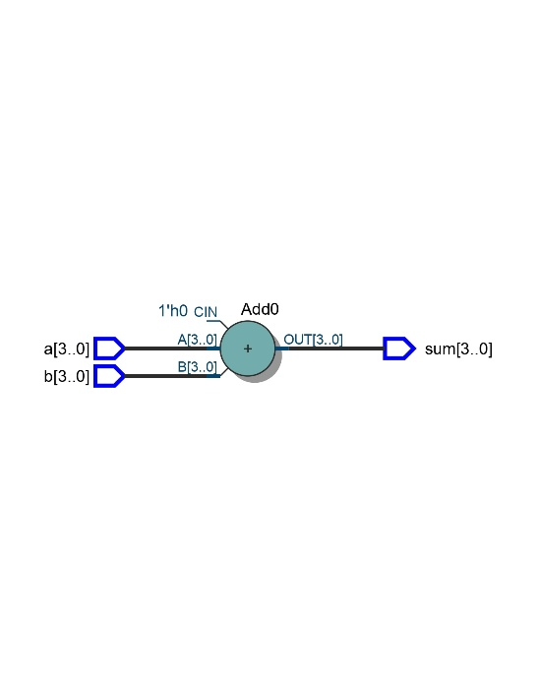
Figure 1: RTL Schematic of OurAdder
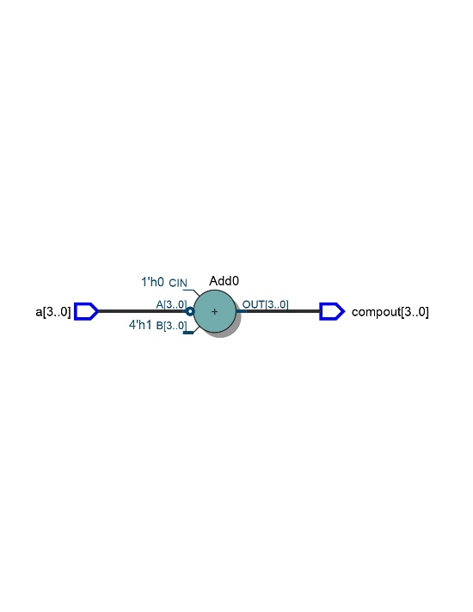
Figure 2: RTL Schematic of OurComplementer

2)
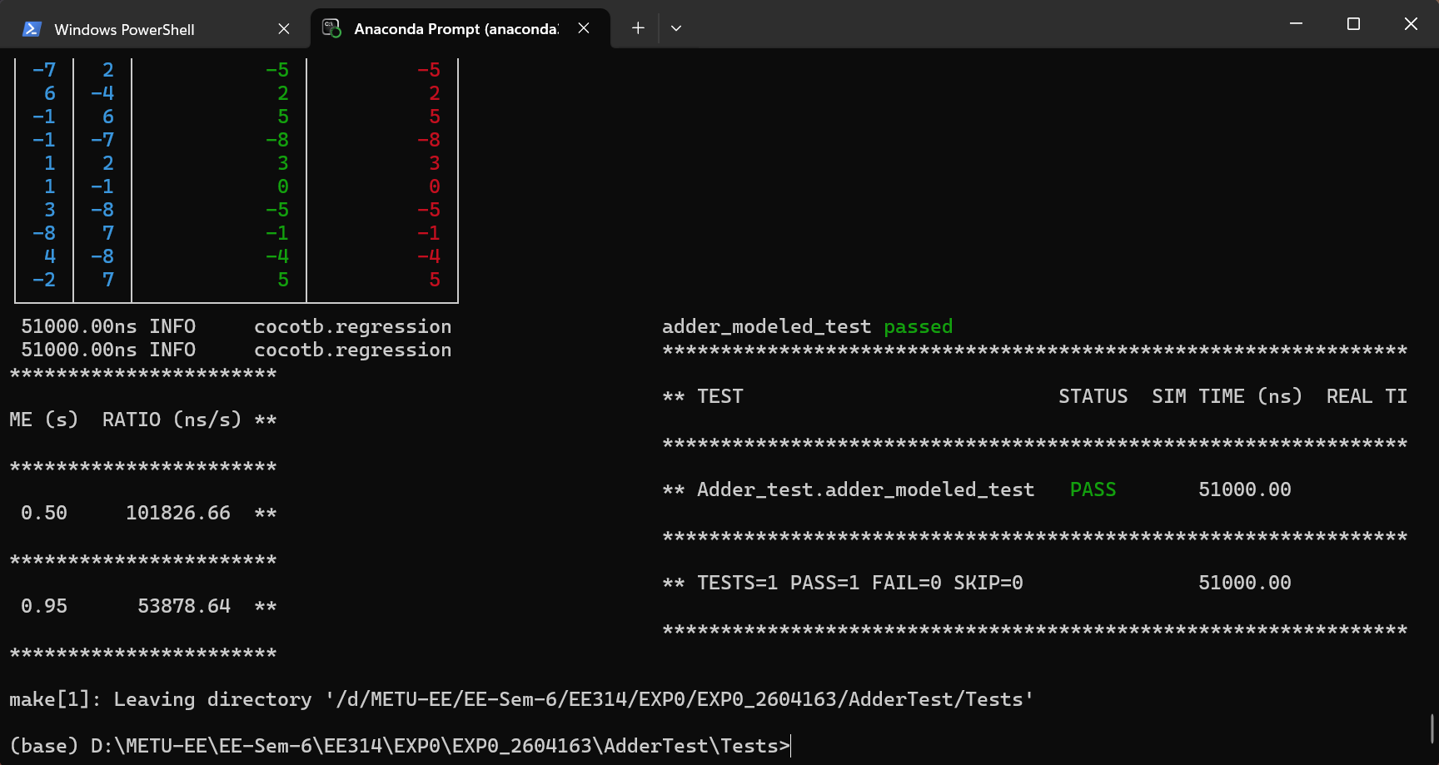
Figure 3: Test Results for OurAdder
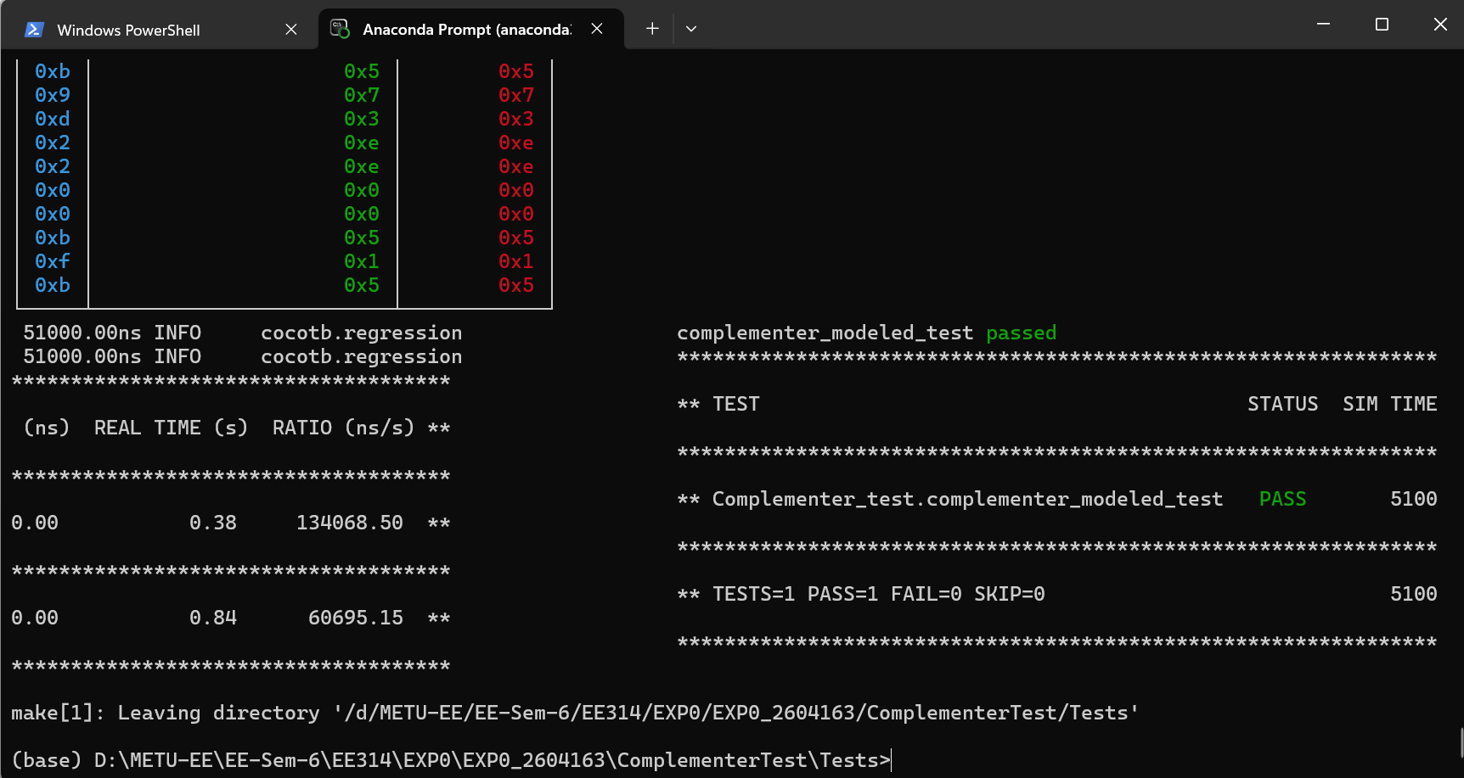
Figure 4: Test Results for OurComplementer

3)
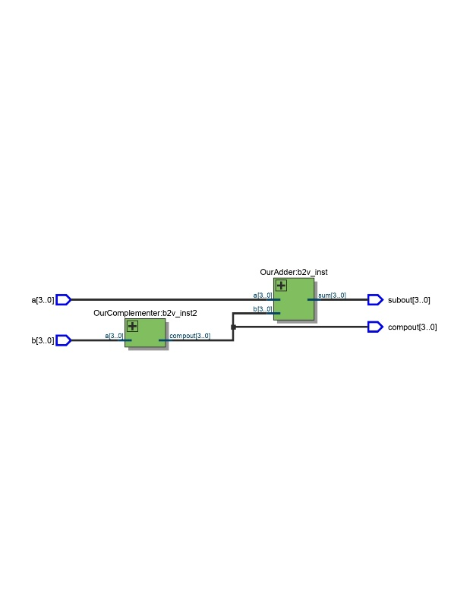
Figure 5: RTL Schematic for OurSubtractor
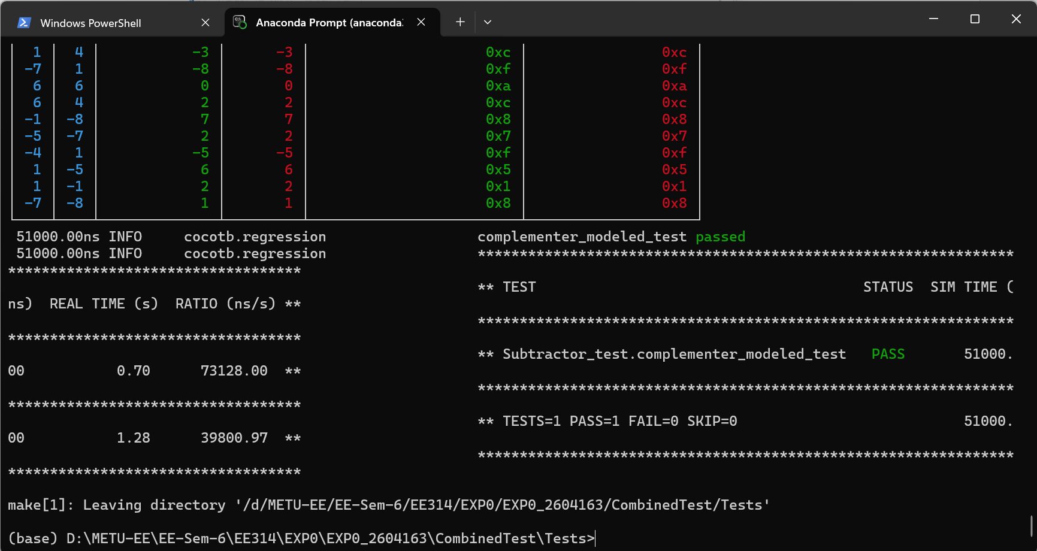
Figure 6: Test Results for OurSubtractor

